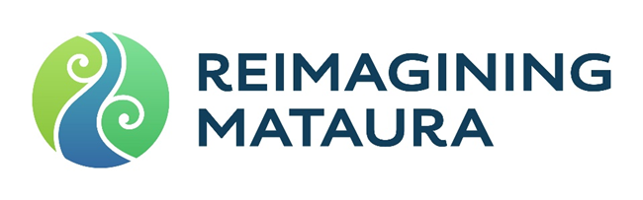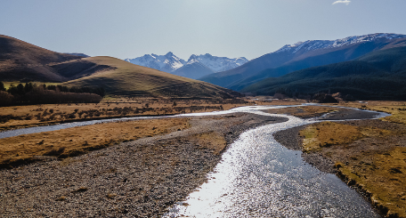

Local & Central

Government Wānanga

# CHALLENGES OR OPPORTUNITIES

|  |  |
| --- | --- |
| * Getting everyone to work together * Statutory frameworks/ legislation – different riles from hierarchy * Overarching rules and regulations hindering local process * Over regulation * Managing risk adversity * Change of mindset * Bringing communities along for the journey * Working with communities to make sure all voices are heard, understanding multiple viewpoints * Commercially gain/ environmental degrades * Communications at all levels * Getting started, keeping momentum * Resourcing – people, money time * Balancing workloads with new initiatives * Distractions * Moving forward with strategic direction * Succession planning and implementation * Capacity and reputational risk * Funding * Resourcing * Responsibilities unclear * Continued silos * Social license * Waste management, and the infrastructure to support a shift * Conservation order currently in place – is this still fit for purpose? * Rules are currently driving behaviours * Government drivers at all levels – global, national, regional * Pest plants and reinfestation – and significant ongoing maintenance | * Rhetoric/ division that drive a lack of action and responsibility * The fast irreversible change of land use around the catchment (forestry) * Transparency around tangible benefits: invisible positive externalities; quantifying long term environmental benefits against the much more tangible financial benefits * Climate change adaption * Time frame (long time to have a significant impact): restoration may be multiple generations away; short council election cycle; growing indigenous vegetation may take a long time * Learning from the past, but not being stuck in it * Access/ ownership rights are garmented * Health and safety, liability, landowner responsibility – risk * Short term barriers/ step back for long term goals * Deciding how to tell the story * Whether the next generation sees value in the outdoors with current technology * Legislative barriers – Resource Management Act * Land loss (private property rights) * Budgets/funding – collective budgeting; cost neutral budgets * Working together * Grass roots/ community led approaches and providing support * Regulations * Funding * Partnership * Not seeing progress in a timely manner * How to turn the Mataura into BAU work * Regional leadership has power to drive aspirations, and $ to drive and accountability * Getting to a ‘broad church’ * Having honest conversations |



Local & Central

Government Wānanga

# ASPIRATIONS AND GOALS

|  |  |
| --- | --- |
| * State of hauora for the long term, that is about the river, for the community, holistic and interconnected * Enhancement of Mauri as an outcome of above * World leading in innovation – leading multiple disciplines including interconnectedness * Total buy-in from everyone * Creating resilience through adaptive management * Replenishable and sustainable environment – we are valuing the asset * Transforming mindsets * Knowing baselines and understanding trends and pathways for improvement * Monitoring and seeing improvement over time * Biodiversity enhancements and improvements * Positive interactions and interventions from humans * Communication and collaboration between stakeholders * Ki uta ki tai, hauora, resilience * Integrated approach for interaction * Finding an innovative path through regulations * Native species – biodiversity not threatened * Better than what we have * Reduce impact of high flow events * Explore land use and repurpose to support a healthy awa * Planned approach to repurpose land, with vision and outcomes * Integrated management of mountains to the sea * Regulatory system that works for us * Innovations is a shared risk and opportunity * Connecting people to the river * To get reimaging Mataura onto every balance sheet * Aspire to having a ‘broad church’ | * Higher percentage of people having a connection to the awa – education, recreation * Access to the waterways * A council that covers the entire Mataura River catchment – a holistically managed Mataura River * A solution to fix the damage done by industry/ others past mistakes by recreating side braids in a design suitable for habitat * Greater investment from the public into projects/ decisions relating to the river * Education * Maximise biodiversity gains/ restoring hauora – from Hectors dolphins on the coast to non-migratory galagids up at the headwaters * Councils being a leader in how forestry and other council owned land is managed going forward * Restoring Mataura falls * When river is in flood, take the opportunity to consider wetland and biodiversity opportunities * Whitebait ponds * Good technical support – regular hui, practical support along with technical support * Connectivity * Holistic view * Collective vision of the whole system working towards an ultimate outcome – the right solution at the right time * Guideline approach, rather than hard legislative reform * Acknowledge ‘ways of the past’ but educate for the future * Core components of any vision include - wellbeing of the awa; flood risk innovation; use of water * Riparian planting * Education – data and information with context; monitoring programme * Innovative approach to work – try, be agile, fail fast within defined parameters |

# WHAT COULD WE START WITH TODAY?

|  |
| --- |
| * Identify easy projects to start with – gravel extraction options/ examples * Alignment of planning with LTP process * Sharing work programmes and plans across agencies * A Mataura River group across parties * Data sharing and collaboration |