# Reimagining Mataura Video Competition

The [***Reimagining Mataura***](https://www.reimaginingmataura.org.nz/) Video Competition is now open!

The competition will close on Friday 19 May 2023.

## Purpose of the Reimagining Mataura vid**eo competition**

The purpose of the competition is to capture and understand the student’s connections and aspirations for the Mataura River.

Your submission should seek to evoke emotion and highlight your storytelling and research abilities; your stories could be humorous, sad, or academically informative.

This video competition is an opportunity for students and ākonga to practice storytelling and research and learn about the Mataura River’s history. Videos can be made using English and/or te reo Māori. Videos may have no dialogue at all, and that is okay.

## Eligibility

* This competition is open to students and ākonga in years 5-13.
* You can submit your project as an individual, a team, or a kura.
* You must be enrolled at a registered school/kura, or group of registered schools/kura, such as a Community of Learning | Kāhui Ako.
* Each video must have one lead producer to serve as the main point of contact.

Recognition and prizes will be given to the lead producer and all those listed as co-producers on the entry form.

**Note**: The only compensation for submitting a video is the opportunity to be awarded a prize. No other payments will be made in relation to the competition.

## How to enter

* To enter the competition, complete the required forms and email them to us at [reimaginingmataura.org.nz](mailto:reimaginingmataura.org.nz), along with a link to your video.
* Make sure the email has ‘Reimagining Mataura Video Competition Submission’ in the subject line.
* The whole entry form must be completed when you upload your video for it to be eligible.
* You must also include a transcript of your video as a document and attach it to the email.

Students and ākonga should keep at least one copy of their video. The Reimagining Mataura team is not responsible for any lost videos.

## Required forms

* Reimagining Mataura video competition entry form [Appendix 1]
* Consent form (for anyone who appears in the video) [Appendix 2]

## Uploading your video to YouTube - Unlisted

To upload your finished video as an unlisted version to YouTube, please follow the steps below:

1. Sign in to your YouTube account or follow the instructions to create one.
2. Go to ‘Your Channel’ and select the ‘upload video’ button.
3. Click the ‘select files’ button and choose your video.
4. Fill in the video details, elements, and checks.
5. On the visibility tab, select the ‘unlisted’ option.
6. Once uploaded, select the options button (three vertical dots) and click on ‘Get shareable link’.
7. Paste the link into your video submission email – only those with the link will be able to access your video.

## Judging

The judges will focus on the following criteria:

* ability to tell the story (how can the viewer get a sense of the Mataura River)
* ability to evoke an emotional response.
* how the video is entertaining or thought-provoking, and
* original artistic flair.

## Prizes for students and ākonga and their kura

Prizes will be announced and presented at the Reimaging Mataura Wānanga, date TBC in June 2023.

**1st Prize** is a GoPro Hero 9 for the associated school and $100 Warehouse vouchers for up to four participants.

**2nd Prize** is $50 Warehouse vouchers for up to four participants.

**3rd Prize** is $20 Warehouse vouchers for up to four participants.

## Appendix 1 - Reimagining Mataura video competition

## Entry form

|  |  |  |  |  |  |  |
| --- | --- | --- | --- | --- | --- | --- |
| Producers Name: | |  | | | | |
| Producers/Students/ Ākonga Year: | |  | Producers Phone: | |  | |
| Co-Producers Names: | |  |  | |  | |
|  |  | |  | |
|  |  | |  | |
| School/kura Name: | |  | School/kura Phone: | |  | |
| School/kura Address: | |  | | | | |
| Name/s of teacher/s who supported student/ākonga: | | | | | | |
| Teacher’s Email: |  | | | Would you like future Video Competitions forwarded to you? | | YES / NO |
| Specify here the sources used by the student/ākonga to produce the video (e.g., Relative, Book, Website, etc): | | | | | | |

Verification of Authenticity

I agree to the conditions of the competition as outlined in the rules. This Video is my original work and all direct quotations have been acknowledged. I give the Reimaging Mataura permission to publish and/or exhibit my video in line with the purpose of the competition (to be authorised by both the student/ākonga and a parent or whānau member).

……………………………………………………………….. Signature of Producer

…………………………………………………………………Name and signature of parent or whānau member

[I confirm that I have the necessary authority to give this permission]

…………………………………………………………………Signature of Supervising Teacher

## Appendix 2 – Consent Form – photos/video/artwork

Permission to allow the Reimagining Mataura to use photos/video of you or your child (or artwork produced by you or your child) to be used for promotional purposes.

THIS CONSENT FORM MUST BE FILLED OUT AND SIGNED BY THE PARENT OR LEGAL GUARDIAN OF THE PERSON NAMED BELOW IF THAT PERSON IS UNDER THE AGE OF 18 YEARS.

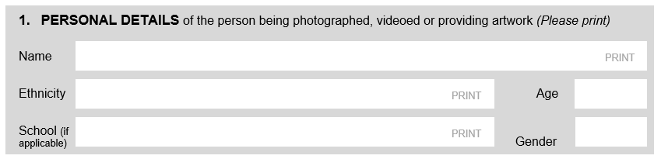

## Terms of use

Photos/video/artwork may be used in any Reimagining Mataura promotional materials in both print and electronic media, such as websites and social media. This also includes promoting the recipient with media organisations.

|  |  |
| --- | --- |
| **Photos** - Photos may be edited or formatted for print or online.  **Video**- Video footage may be edited and published online.  **Artwork** - You or your child retain the copyright. | **Respecting your privacy**  The personal details you provided in Section 1 are confidential and will be stored securely by the Reimaging Mataura project;  You have the right to access and request correction of your personal information;  You have the right to request, in writing, that the Reimagining Mataura stop using your photos/video/artwork. |